What You MUST know for the Test

Answers to all questions, numbers T8A01, page 11.46 through T8F21, page 11.61

T8A – Basic Station Apparatus, Setup and Layout

- Dual band hand-helds are most commonly 2 meters and 70-cm
- If your mobile works in the car, but not at home, check that power supply!
- You need a computer to do data emissions.
- Weak signal VHF would require a multi-mode transceiver.
- You need a microphone for voice. (DUH!)
- You need a telegraph key to send Morse code.
- To send good Morse, use and electronic keyer.
- Filtering the power supply helps eliminate AC hum on CW.
- Filtering the DC power supply on a mobile reduces stray noise and RF pick-up.
- For RTTY, use a modem and teleprinter, or a computer.
- Between the transceiver and an antenna switch, you might put an SWR meter.
- If you set the squelch too low on packet, the TNC might detect false data.
- Transmit RTTY on VHF/UHF with an FM transmitter and a modem.
- A duplexer connects a dual band antenna to a transceiver with separate VHF/UHF outputs.

T8B – Transmitters

- A transceiver designed for FM phone on 2-meter can only be used for SSB if it is a “multimode” radio.
- CW is transmitted by on/off keying of the RF signal.
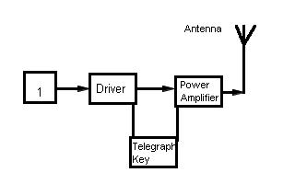

- In the above simple, VFO-controlled transmitter CW transmitter, block 1 is a variable-frequency oscillator, and controls the transmitter frequency.

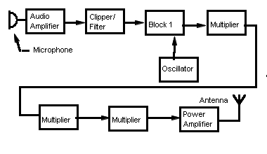
- In the above FM transmitter, Block 1 is a reactance modulator, and if the audio amplifier failed, the output would be an unmodulated carrier.
- A dummy antenna for a 100-watt SSB transmitter should have a minimum rating of 100 watts.
- You can operate your mobile at home with a power supply, which converts 120 V AC to 12 DC, or you can use a 12 battery.
- A power amplifier can boost your hand-held signal up to 100 watts.
- Over deviation on an FM transmitter causes out-of-channel emissions.
- If you are told that you are over-deviating, talk further away from the microphone.

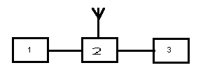

- In the above, if 1 is a transceiver, 2 is an antenna switch, and 3 is a dummy antenna.
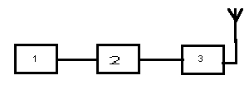
- In the above, 1 is a transceiver, 2 is an SWR meter, and 3 is an antenna tuner.

T8C – Receivers

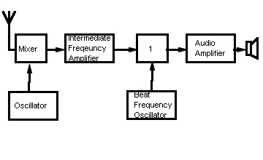
- The above is a simple CW/SSB receiver, and Block 1 is a product detector

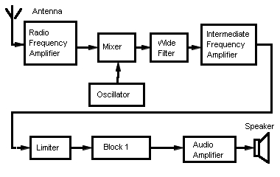

- In the above FM receiver, Block 1 is a frequency discriminator, and if it failed, there would be no audio output.
- All types of receivers contain a detector.
- Tune to WWV or WWVH to check the calibration of your receiver’s tuning dial.
- A detector circuit combines signals from an IF amplifier and a beat-frequency oscillator (BFO).
- FM voice is effective because it’s audio is less affected by interference from static.
- Some emission types need a wider bandwidth that others, so we have selectable IF filters.
- The mixer in a superheterodyne receiver shifts the frequency of the received signal.
- Set your FM squelch to the point where it just cancels background noise.

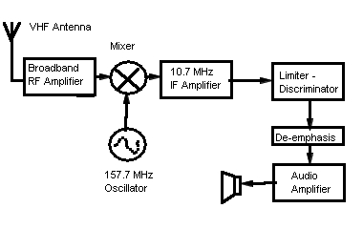
- The single-conversion, superheterodyne receiver above, could detect FM signals at 147.0 MHz and 168.4 MHz (HINT : 157.7 – 10.7 = 147.0, and 157.7 + 10.7 = 168.4)

T8D – Antennas

- An external antenna will help your handheld “get out” better from inside your car.
- “Rubber duck” antennas are less efficient than a ¼ wave telescopic.
- A half-wave dipole for 147 MHz is 37”.
- A half-wave dipole for 223 MHz is 25”
- A quarter-wave vertical for 146 MHz is 19”
- A quarter-wave vertical for 440 MHz is 6”
- Boom length has the greatest effect on the gain of a properly designed Yagi.
- The driven element of a Yagi is approximately ½ wavelength.
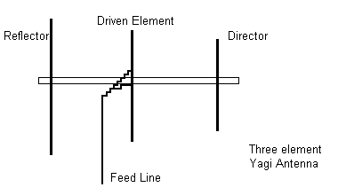
- A cubical quad is two or more parallel four-sided wire loops.
- A horizontal polarized wave has its electrical lines of force parallel to the Earth’s surface.
- A vertical polarized wave has its electrical lines of force perpendicular to the Earth’s surface.
- Most VHF/UHF repeater antennas are vertically polarized.
- Satellite signals are circular polarized.
- Weak-signal SSB is horizontally polarized.
- If the ends of a dipole point east/west, most of the radio energy will go north/south.
- Increasing gain by 3dB will double the signal’s effective radiated power.
- Multiband antennas allow you to operate on several bands with only one feed line.
- Add a loading coil to reduce an antenna’s length.
- An antenna tuner might allow you to use an antenna on a band the antenna is not designed for.

T8E – Transmission Lines, SWR

- Standing-wave ratio (SWR) is the ratio of maximum to minimum voltages on the feed line.
- You use an SWR meter to measure standing wave ratio.
- An SWR of 1:1 means the impedance of the antenna and the transmission line is matched.
- An SWR of 4:1 means a mismatch; something’s wrong!
- An antenna tuner matches the transceiver output impedance to the antenna system impedance.
- Coaxial cable (“coax”) is a center wire inside an insulating material, covered by a metal sleeve or shield.
- You should use good quality coax to keep RF loss low. RF loss generates heat in the cable.
- Parallel conductor line is two wires side-by-side held apart by insulating material.
- Parallel conductor wire will operate well, even with a high SWR, and has less loss than coax.
- “Balun” means Balunced to unbalanced.
- Install a balun between the coax and the antenna.
- An unbalanced line is a feed line with one conductor connected to ground.
- The “feed point” is the point at which the feed line joins the antenna.

T8F – Meters and Measurement

- A voltmeter is used to measure electric potential and is connected in parallel.
- Switching a voltmeter to a higher range adds resistance in series with the meter.
- An ammeter measures current, and is connected in series.
- An ohmmeter measures DC resistance.
- Measuring voltage when the meter is set to measure ohms might damage a moving-needle type multimeter.
- Use a multimeter to measure, voltage, current or resistance.
- An S meter measures relative signal strength at a receiver.
- “Forward power” is the power traveling from the transmitter to the antenna, “reflected power” is the power returned towards the source on a transmission line.
- If we read 90 watts forward and 10 reflected, the actual output is 80 watts.
- Most RF watt meters operate at 50 ohms. impedance.
- As a Technician, you can build your own equipment!
- When soldering, wear safety glasses, ensure proper ventilation, and don’t touch that tip!! (In other words, all of the above!)
- If you suspect that the supply voltage is too low when you transmit on your 12-volt transceiver, check the voltage at the power plug on the radio.
- If your mobile unit will not power up, check the fuses first.
- A signal generator produces a stable, low-level signal of a desired frequency.

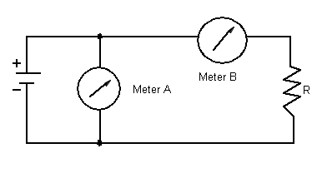
- In the above, Meter A reads Battery voltage, Meter B reads the current through the resistor, and the power consumed by the resistor is calculated by multiplying the value of the resistor by the square of the reading of Meter B.

Things You Should Know

This is big chapter, making up over 17% of your test! (Which is why these notes are 4 pages long.)
There’s a lot of basic information here, however, that you need to become a good operator. Pay special attention to the sections in this chapter that explain how to hook up your equipment, especially good grounding, feed lines, and antenna hookups.

If you take nothing else from this chapter, learn about SWR; how to measure it, and how to adjust it. A bad SWR can actually burn out your radio! Although modern radios normally are equipped with circuits to help prevent this,

