Northeast Iowa Radio Amateur Association
WØMG MEETING MINUTES; 08 March 2014

The March meeting of the Northeast Iowa Radio Amateur Association (NIRAA) was held at 7:00 pm at the American Red Cross building in Waterloo on March 8, 2014.

President Dave Knittel (KØCQH) called the meeting to order at 7:04 pm, and a sign-up sheet was passed for attendees to sign.

Nineteen (19) attendees signed in: Mark Colby (N8TWO), Chuck Angel (WØALO), Scott Lowe (WAØTPN), Dave Knittel (KØCQH), Stan Johnson (WØSJ), Eric Henely (KBØQND), David Brandon (WDØBWQ), Curtis Wilson (NKØT), Wendell Wagner (NØRXB), Rich Jones (KBØQAV), Dave Kelly (KDØDK), Dick Nelson (WØHHF), Judi Nelson (NØHHF), Tom Bicket (AEØTB), Chris Conklin (NØCF), Gary Korte (KØRTE), Nathan Fisher (NØZYC), Taryn Colby (guest), Ron Sindric (WD8ODM/expired).

Introductions:
Each person present introduced themselves and members and guests were welcomed.

Secretary and Treasurer’s Reports:
Treasurer, Scott Lowe: As of March 8, 2014, the balance in the Veridan bank account is $ 661.39. The motion was made (Brandon), seconded (J. Nelson), to accept the Treasurer’s Report. The report was approved.

A motion was made (Angel) and seconded (Brandon) to approve the Secretary’s Report and was approved as posted on the NIRAA website.

New Business:
- Tom Bicket and Charlie Angel attended the Iowa Section ARES Meeting in Boone where a discussion on the use of digital mode on 80m HF took place. They reported that we might want to consider using FLDigi to transmit forms on VHF and UHF.

- A Memorandum of Understanding (MOU) was formulated with the State Hospital Association that ARES groups will respond in emergencies. Hospitals are looking for back-up communications systems to include in their required Emergency Plans. There is a PSK-31 net every Tuesday evening at 7:00 PM on 3.574 MHz.

- Next VE session will be Saturday, April 26, 2014 in the Curtis Business Building on the University of Northern Iowa Campus. It is located at the intersection of 27th and Minnesota Streets; rooms 1 & 3, 10:00 AM.

- Dave Knittel (KØCQH) will contact ARRL to reestablish our clubs affiliation with ARRL. Thanks to all of you who responded to the inquiry about whether, or not, you were an ARRL member. It appears we have 64+% membership.

- Weather Spotter Training: March 24, 2014 (Monday), 6:30 PM, Tama Hall, on the Hawkeye Community College campus.

- Upcoming hamfests/swapmeets:
  - Oscaloosa, Iowa, March 15.
  - Princeton, IL (Starved Rock), Sunday, June 1.
  - WØMG, Saturday July 12, Island Park, Cedar Falls, 8:00AM – Noon.

Charlie Angel (WØALO) moved and Mark Colby (N8TWO) seconded to adjourn. Meeting adjourned.

Program: Dick Nelson did a presentation the ARRL 100 year Centennial and on the Centennial QSO Party. A movie showing the history of ARRL on a timeline was shown with the hopes of showing what ARRL has done for the hobby as well as the reason why we should all support the organization. Without the ARRL, there would be no ham radio.

Dick discussed the year-long Centennial QSO party, some of it features, and requirements to participate. He forgot the flash stick that contained a Power Point presentation, so had to “wing it”. A .pdf of the Power Point slides is being attached to these minutes.

Next month’s program TBD.

Submitted by:
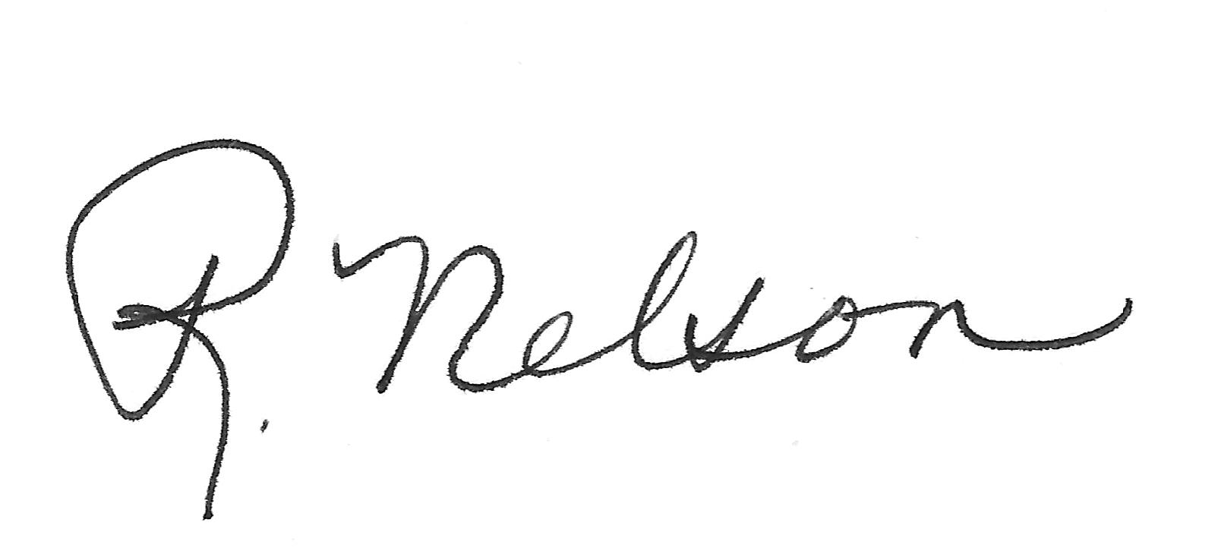
Dick Nelson, Secretary
W0HHF@arrl.net

