MINI DV Manual

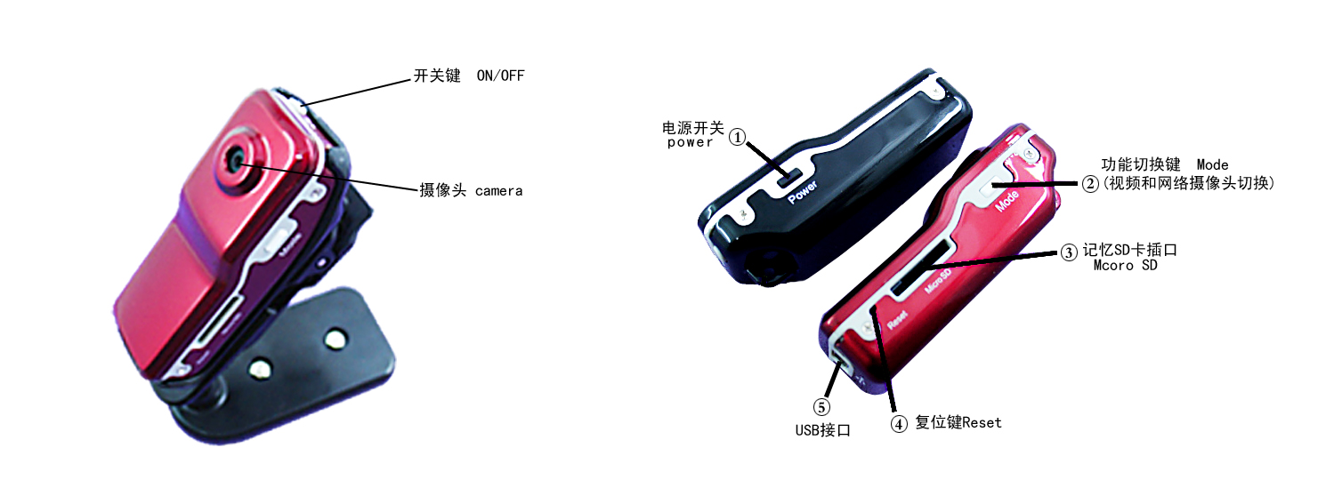

Thank you for your purchase MINI DV, this machine uses a unique design, it can be applied in various fields, for your convenience, security and colorful daily life.

一．Features

- Compact design, wide product UV coating machine, wearable and fashion and a variety of portable tools
- Support net-camera, it has net-chatting function.
- Support AVI video format
- The high-definition images also can be recorded in the weak illumination
- Support 720 * 480 video resolution and 30 frames per second video recording speed.
- Support the common USB1.1 and the USB2.0 interface with high-speed transmission
- The maximum size of T-flash card is 8G
- The power of the built-in lithium battery can last for 2 hours’ videoing and the standby time is 250 hours.
二．Operational Guidelines

1. Recharging:

There is a built-in rechargeable lithium battery in this machine, please charge it before the first time you use it ,you can charge MINI DV through the following ways:

1), Computer connective charging, you can charge it by the connection with computer through USB data lines.
2), Using the rechargeable battery charger, you only need to connect the charger with USB data lines and plug the charger on the socket ,then the machine is being recharged .The red light and green light will have the same brightness when the machine is being recharged and they are both in the static state.
Note: When the battery power is insufficient, D001 will go to the protection state directly, you can not boot. At this time, please charge the machine.

2. Boot and video

Press the Power button, when the red indicator turn on, the machine is on the boot preparation state, and then convert into standby mode immediately. Press the Record / Stop button on the top, and the red light will always lighting, then the green light start to flash slowly and this machine begin to video. The file-resolution is: 720 * 480, the frame is: 30fps / S. Press the Record / Stop button shortly to stop recording, and it will save the file automatically. After that the red light still always lighting. If you need to continue videoing, please re-touch Record / Stop button.

Note:

a. Please make sure DV has been inserted into T-flash (Micro SD) card, if there is no card, DV will turn off after 30 seconds automatically.
b. The maximum capacity of the T-flash (Micro SD) is 16G.
c. The file preserving needs a certain period of time, do not press any key continually during this time, it will lead the file can not be preserved successfully and the generated file will be incomplete.
d. Please use the camera in the adequate lighting environment, the camera lens should be aimed at the photo of the image and keeped the distance more than 50cm from the object. Then you can get correct, natural coloured, clear, stable images.

3. Sound control video

Press the Power button and the red indicator turn on, the machine is on the boot preparation state, and then convert into standby mode immediately. Press the MODE key at this time, it will switch to voice-activated camera mode. The red light will always lighting this time and the green light flash quickly (instructions for the voice standby mode). D001 will start the video recording automatically when the sound at the video site is more than 60 db. At this time, the red light still always lighting, but the green light flashing slowly (instructions for the voice-activated videoing).
After the beginning of voice-activated video, the minimum time for each video recording is 2 minutes. If after the two minutes of video recording, the video site is silent, D001 video files will be saved automatically and the machine will switch to standby mode. If there still have sound, DV will continue recording.
4. Set up the time

There is a file in the attached disk,it is for time synchronization,pls copy this file to the TF card,and connect it with the PC,the native machines’ time will synchronously change the time the same as the PC.

The detailed usage is as follows:
- Build a text file,put TAG.TXT as it is name.
- Open the Tag.TXT file,according to the attachments’ form,write the requested synchronization time.
The detailed form is as follow:
[date] <blank and newline is needed>
2009/07/22 <blank and newline is needed>
12:00:00

CHKDSK is verifying the TAG.TXT file everytime when you boot-strap.and according to the tiem,it will set system time.after setting the system time,the TAG.TXT file will be delete automatically.

5. Shut off the machine
In the video or standby state, press the Power button 3 seconds, release the button until the indicator light is off. It means the machine has been shut off.

6. Automatic shut-off function:

In the following circumstances: MINI DV will save the video data and shut off automatically.

a. The machine is lack of electricity when you are videoing. The system will save the video content first, and then shut off automatically.
b. When the MINI DV disk space is full, after the indicator light flashing instantaneously, the machine will save the file and shut off automatically.
c. In the standby mode, without any operation for 45 seconds, the system will automatically shut off.

7. Connect the computer

In the state of off-the-power, standby mode or videoing mode, the machine can be connected to the computer directly. It can be used as a U disk after that and the document can be freely copied, pasted, deleted.

Insert the machine into the computer USB port, the removable disk logo will appear after a few seconds. The red light will always lighting, the yellow light will flashes instantaneously first and then always lighting.

Tips:

a. After connecting the computer, if the computer does not recognize the machine or there is still no removable disk logo after 30 seconds, please re-plug it again.
b. Proposing copy or shear the well-recorded video file to your computer hard disk first and then display it. If you broadcast the file in the recorder's built-in video memory directly, the play may be not smooth, it is probably because the data is excessive and the data transmission can not keep up.

8. PC Video Camera Features:

You should install the driver before you first use D001 as a PC video camera. The driver named SPCA1528_V2220_M ... Setup.exe, it is in the gifted CD. Double-click the file, follow the installation prompts to complete the installation, there will have a AMCAP icon on the desktop after installation.

In the state of off-the-power or booting, use USB lines to connect the computer, the state is the U disk mode, shortly press MODE button, it will switch to the computer video camera mode at this time. Click the icon AMCAP, then it can be used as the computer video camera.

9. Reset:

When the machine doesn’t work because of illegal operation or other unknown reasons, you need to reset the product.
Specific methods are: use a rod to click on the reset button, then the reset operation can be done.

10. Notes

Use limits: Please strictly observe the relevant national laws, this product can’t be used for any illegal purpose, or you must be responsible for the consequences.

Software upgrade: In order to let the products have better performance, manufacturers will continue to improve the product software, this product has a feature that users can upgrade the software by themselves conveniently. Please contact the local dealer to obtain the information of the latest version about the software and the upgrade methods.

Operating temperature: Please use it in the natural temperature, don’t use it in the temperatures that the human body can not adapt to.

Working humidity: Please use it in the suitable living humidity environment for human. Please don’t put the product in the humid environment. It does not have the waterproof function. Please avoid exposing this product to rainwater.

Shooting illumination: Please use it in the environment with sufficient illumination. Do not let the camera face such as the super-solar light sources directly in order to avoid damaging the optical devices.

Cleaning requirements: Do not use it in the environment that the dust density is too large, in order to avoid the camera and other parts contaminated dust and influence the result of videoing.

Deal with the disposal: Please pay attention to the environmental protection, don’t discard this product freely. Throw this product in the fire is prohibited in order to avoid an explosion.

